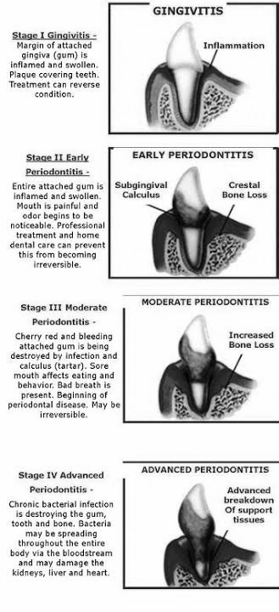
What Does Dental Disease Look Like?
- Bad breath
- Tartar buildup on teeth
- Redness at the gum line
- Broken/loose or discolored teeth
- Drooling
- Bleeding gums
- Trouble eating or loss of appetite

Things to do at Home:

Brushing with toothpaste:
- Pet-specific toothpaste (from vet office or pet store)
- Traditional toothbrush or finger brush

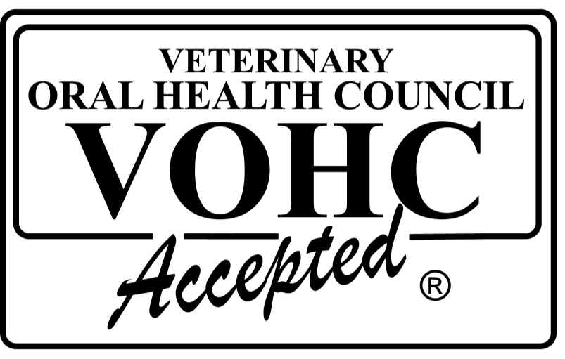
Dental Care Treats:
- Greenies
- Milkbone
- Dentastix
- Look for treats with the VOHC logo: these have been tested by the Academy of Veterinary Dentistry

Dental Diet:
- Prescription food available through vets
- Over-the-counter foods with the VOHC seal
- Help with tartar buildup

Professional Dental Work:
- Needed to prevent and reverse periodontal disease -- frequency is different for each animal
- Done at a vet office under general anesthesia
- A thorough dental exam can easily be done while animal is anesthetized, including X-rays
- All teeth are scaled above and below the gumline with an ultrasonic scaler, then polished

Extractions:
- If a tooth is diseased enough, it will need to be extracted
- Extractions can occur during a dental cleaning
- Gum is sutured after extraction
- Animals with extractions may need antibiotics afterward

Referrals for Dental Cleaning/Extractions (continued on back page):

- City Cat Vets (cats only): Ranges from $600-$1000
  - 2210 South Street, Philadelphia PA 19146
  - 215-545-2287

- Glenolden Animal Hospital: $64 for dental evaluation
  - 405 S MacDade Blvd, Glenolden PA 19036
  - 610-237-6120

- Philadelphia Animal Hospital: $398, including bloodwork
  - 7401 Holstein Avenue, Philadelphia PA 19153
  - 215-724-5550

- Dutton Road Veterinary Clinic: $40 for dental evaluation
  - 10901 Dutton Road, Philadelphia PA 19154
  - 215-331-2968

- Providence Animal Center (does not do dental x-rays)
  - 555 Sandy Bank Road, Media PA 19063
  - 610-566-1370

